Cultural Genes, Economic Geography, and Innovation Network Dynamics: Multidimensional Evidence from Chinese Prefecture-Level Cities
Abstract
This study develops and tests a model of innovation network evolution driven by the interplay of cultural genes and economic geography. We mathematically couple Joel Mokyr’s “Bridge-Filter” theory of cultural growth with the Berliant-Fujita (BF) model of knowledge creation, proposing a framework of “Effective Diversity.” Using a panel dataset of 329 Chinese prefecture-level cities from 2001-2023, our research yields three key findings. First, cultural diversity exhibits an inverted U-shaped relationship with innovation network centrality, confirming the existence of an optimal diversity threshold that is endogenously shaped by cultural bridge and filter mechanisms. Second, we identify significant dual spatial dependencies: cultural similarity and geographical proximity jointly determine the probability of inter-city innovation linkages, with a 100km increase in geographical distance requiring a 12.7% increase in cultural similarity to maintain constant linkage strength. Third, policy-induced “cultural mutations,” simulated via an agent-based model, can enhance a core city’s network weighted degree by up to 35.6%, though this effect is constrained by geographical friction. This research provides robust empirical support for a cultural new economic geography and offers targeted policy recommendations for fostering innovation, such as constructing “cultural corridors” and managing diversity thresholds.
Keywords: Cultural Genes; Innovation Network; Spatial Econometrics; Mokyr-BF Model; Effective Diversity; Agent-Based Modeling; Chinese Cities
1. Introduction
1.1 Research Background and Problem Statement
Why do some cities and regions become persistent innovation hubs while others lag? A vast literature in economic geography points to agglomeration economies, knowledge spillovers, and network externalities as primary drivers (Glaeser et al., 1992; Audretsch & Feldman, 1996). Empirically, innovation activities are not randomly distributed across space but form complex network structures where cities act as nodes and inter-city collaborations form the edges (Acemoglu et al., 2016). Recent studies focusing on China reveal a distinct and evolving network topology. The national innovation network exhibits a clear core-periphery structure, which has gradually transitioned from a single-core (dominated by Beijing) to a multi-core "diamond" structure, with major hubs in the Beijing-Tianjin, Yangtze River Delta (Shanghai-Nanjing), Pearl River Delta (Guangzhou-Shenzhen), and Chengdu-Chongqing regions (Li & Phelps, 2017; [引用文献综述中的来源 [1]]).
While the structural dynamics of this network are increasingly well-documented, the underlying drivers of its evolution remain a subject of intense debate. The dominant explanations focus on economic fundamentals, technological proximity, and institutional factors. Yet, the role of culture in this process is often treated as a contextual backdrop rather than a core production input. This represents a significant research gap, as deep-rooted cultural attributes—or "cultural genes"—may fundamentally shape the migration patterns of innovative agents (talent, firms) and the costs of inter-city collaboration, thereby steering the network’s evolution ([引用文献综述中的来源 [8], [9]]).
This paper challenges the conventional view by proposing and empirically testing a framework where cultural attributes—specifically diversity and the mechanisms that manage it—are central to the formation and evolution of innovation networks. We ask: can cultural factors explain why certain cities rise to become network hubs? And how do cultural traits interact with geographic distance to determine the landscape of knowledge flows?
To address these questions, we formalize the link between culture and innovation. We begin with the micro-foundations of knowledge recombination, as modeled by Weitzman (1998) and Berliant and Fujita (BF) (2008), where new ideas arise from combining existing knowledge. We then argue that culture provides the macro-level structure governing this process. Specifically, we integrate the BF model with Joel Mokyr's (2016) evolutionary theory of cultural growth. Mokyr posits that progress depends on two countervailing forces: ‘bridges’, which expose a society to novel ideas, and ‘filters’, which select and institutionalize the most promising ones. We contend that these mechanisms directly regulate the productivity of a city's knowledge recombination process. So, this paper addresses a central question: How do the dynamic evolution and spatial interaction of cultural genes regulate economic geography to shape the structure of urban innovation networks?
1.2 Literature Review and Research Gap
Existing literature grapples with this question from three disconnected perspectives, leaving a significant theoretical and empirical gap.
- Cultural Economics: Studies often focus on single cultural dimensions, such as how high power distance inhibits knowledge sharing (Zhou et al., 2021) or how uncertainty avoidance tempers breakthrough innovation (Shane, 1993). This approach suffers from two limitations: it oversimplifies the multi-faceted nature of culture and predominantly assumes a static cultural state, neglecting its dynamic evolution in response to policy and social change.
- Economic Geography: This field powerfully models the role of proximity in fostering knowledge spillovers (Jaffe et al., 1993). Spatial econometric models like the Spatial Durbin Model (SDM) have consistently verified the importance of geographic proximity (LeSage et al., 2009). However, these models typically rely on a monolithic, geography-based spatial weight matrix, largely ignoring the fact that in the digital age, "cognitive" or "cultural" proximity can supersede physical distance.
- Culture-Geography Linkages: A nascent stream of research acknowledges the interplay between culture and geography. Boschma (2005) conceptualized "cultural proximity" as a key enabler of innovation, and Saxenian (2006) provided a compelling case study of cultural ties driving the Silicon Valley-Hsinchu network. Yet, this work remains largely qualitative or relies on static, national-level metrics, failing to provide a quantifiable, dynamic model applicable at the city level.
1.3 Theoretical Framework and Contribution
This paper bridges these gaps by constructing a “Cultural-Geographical Coupling” framework. Our primary contribution is the development and empirical validation of a growth model that mathematically integrates two seminal theories:
- Joel Mokyr’s (2016) Cultural Growth Model: We operationalize his concepts of Bridge Function (inter-group knowledge sharing) and Filter Function (societal selection of innovations).
- Berliant-Fujita’s (BF) Knowledge Creation Model: We adopt its micro-foundation, where innovation arises from the interaction of common knowledge ($n^{c}$) and differential knowledge ($n^{d}$).
By coupling these, we formalize the concept of Effective Diversity ($\hat{H}$), where the raw potential of cultural diversity (Shannon Entropy) is augmented by cultural bridges and diminished by overly restrictive cultural filters. This framework allows us to model the inverted U-shaped "diversity paradox" and explain how the optimal level of diversity is endogenously determined by the cultural environment.
Our research contributes in four significant ways:
- Theoretical Integration: We provide the first, to our knowledge, formal mathematical coupling of the Mokyr and BF models, offering a micro-founded theory of cultural influence on economic growth.
- Methodological Innovation: We propose a multi-dimensional "cultural gene" index for Chinese cities and construct a dual spatial weight matrix that accounts for both geographical and cultural distance, overcoming the limitations of traditional spatial econometrics.
- Dynamic Mechanism: We use a hybrid methodology, combining panel data econometrics with agent-based simulations, to reveal the dynamic transmission of policy-induced "cultural mutations" through the innovation network.
- Empirical Evidence: We provide robust, city-level evidence from China that quantifies the trade-off between cultural diversity's innovation premium and its coordination costs, offering a nuanced explanation for China's innovation geography.
The remainder of this paper is structured as follows: Section 2 details the theoretical framework and the coupled model. Section 3 describes the data, variable construction, and empirical strategy. Section 4 presents the econometric and simulation results. Section 5 discusses the theoretical and policy implications and concludes.
2. Theory and Model
2.1 Knowledge Creation: The BF Micro-foundation
The Berliant-Fujita (BF) model provides the micro-foundation for how interactions generate new knowledge. For any two agents (e.g., firms, cities, groups) $i$and $j$ , their knowledge stocks can be decomposed into a shared common component:
$$n_{ij}^{c}≡K_{i}∩K_{j}$$
and agent-specific differential components:
$$n_{ij}^{d}≡{K_{i}}/{K_{j}}$$
$$n_{ji}^{d}≡{K_{j}}/{K_{i}}$$
For any collaborating pair $(i,j)$, the rate of new knowledge creation$a_{ij}$, following the Berliant–Fujita micro-foundation, the collaborative idea-generation rate is
$$\begin{matrix} & a_{ij}= β (n_{ij}^{c})^{θ} (n_{ij}^{d} n_{ji}^{d})^{\frac{1-θ}{2}},0<θ<1，β>0. & & \text{(1)}\end{matrix}$$
The common knowledge based $n_{ij}^{c}$ enables communication and absorption (weighted by $θ$), while the differential stocks $n_{ij}^{d},n_{ji}^{d}$provide novel inputs for recombination (weighted by $1-θ$). The Cobb–Douglas form
$$a_{ij}=β(n_{ij}^{c})^{θ}(n_{ij}^{d})^{1-θ}$$

implies interior optimality: neither perfect homogeneity ($n^{d}→0$) nor perfect heterogeneity ($n^{c}→0$) maximizes $a_{ij}$.
Following Berliant and Fujita (2008), we define the creation of a new idea or innovation (I) as the outcome of a successful collaboration between two agents (or cities), $i$ and $j$ . Each city possesses a knowledge set. The success of their collaboration depends on the combination of their common knowledge ($K_{c}$) and their differential knowledge ($K_{d}$). Common knowledge is essential for communication and understanding, reducing transaction costs. Differential knowledge provides the novel inputs and varied perspectives that are the raw material for new combinations. So the innovation ideas (I)can come out from the equation below:
$$I_{ij}=F\left(K_{c},K_{d}\right)$$
There is a fundamental trade-off: too little common knowledge hinders communication, while too little differential knowledge leads to redundant, low-value ideas. When concern to space, giving an aggregate (city/region) level $r$, define a recombination efficiency that collects all feasible pairs, weighted by match probabilities and interaction intensity:
$$\begin{matrix} & Φ_{r}≡ \sum_{(i,j)∈r}{w_{ij}\left(B_{r}\right) a_{ij}, \frac{∂w_{ij}}{∂B_{r}}>0}. & & \text{(2)}\end{matrix}$$
The weighting function $w_{ij}(B_{r})$captures how a bridging environment (defined below) raises the likelihood that heterogeneous pairs meet and effectively communicate, shifting the economy toward productivity-enhancing matches.

2.2 Cultural Mechanisms: The Mokyr Network-structure
Mokyr's (2016) evolutionary framework provides a powerful lens for understanding how societies generate and select new knowledge over the long run. We adapt his concepts to the context of a regional innovation system, proposing that they represent the key parameters governing the efficiency of knowledge recombination in a network of cities.
Whereas (1)–(2) describe how new ideas are produced, the cultural milieu determines how many candidate ideas are generated and which are adopted.
(1)Bridge capital and candidate ideas
Bridges are mechanisms that connect disparate knowledge pools, increasing the exposure of local agents to a wider variety of differential knowledge ($K_{d})$. In a modern context, examples include physical and digital infrastructure (e.g., high-speed rail, broadband internet), national scientific conferences that facilitate face-to-face interaction, and open research platforms. A stronger bridge increases the probability of valuable, non-redundant interactions. Let $B_{t}$denote cultural bridge capital (shared codes and standards, inter-community trust, multi-lingual competencies, interoperability), which scales the efficiency of knowledge production. Let $P_{t}$and $T_{t}$be propositional (scientific) and prescriptive/technical knowledge stocks. The flow of candidate innovations satisfies
文化桥接资本、科学技术知识储量，文化资本放大现有知识的产出，提升新思想的产生。

$$\begin{matrix} & {\dot{N}}_{t} =λ(B_{t}) P_{t}^{α} T_{t}^{β},λ^{'}(B_{t})>0, α,β>0. & & \text{(3)}\end{matrix}$$
Higher $B_{t}$magnifies the productivity of existing knowledge bases, raising the volume of candidate ideas.
(2)Filter stringency and adoption
These are selective institutions that vet, validate, and adopt new ideas, thereby enhancing the quality and accessibility of the common knowledge base ($K_{c}$). Examples include the peer-review systems of scientific journals, patent offices that adjudicate novelty, venture capital screening processes that identify commercially viable innovations, and university technology transfer offices. A more effective filter reduces noise and ensures that the common knowledge base is robust and useful for subsequent innovation. Let $F_{t}∈[0,1]$index filter stringency (norms, review/approval thresholds, platform moderation, ethical/quality screens). Let $S(F_{t})∈(0,1]$be an adoption/throughput function with $S^{'}(F_{t})<0$. The adopted innovation flow is

$$\begin{matrix} & A_{t} = S(F_{t}) {\dot{N}}_{t}= S(F_{t}) λ(B_{t}) P_{t}^{α} T_{t}^{β}. & & \text{(4)}\end{matrix}$$
Moderate filtering can improve average quality; overly strict filtering reduces throughput and diversity of adopted ideas.
(3) The Effective Diversity ($H_{t}$) Model
Denote raw cultural diversity (e.g., Shannon entropy) by $H_{t}$. Bridge capital “activates” heterogeneity; filtering “attenuates” it. Define effective diversity
$$\begin{matrix} & Γ_{t}≡ H_{t} (1+ω_{B}B_{t}) (1-ω_{F}F_{t}),ω_{B},ω_{F}>0. & & \text{(5)}\end{matrix}$$
This $Γ_{t}$will enter preferences and innovation technology below, providing a single sufficient statistic that integrates heterogeneity, communicability, and selection.

2.3 Preferences with Endogenous Love-of-Variety (Dixit–Stiglitz)
Each agent in city $r$consumes a homogeneous numeraire and a continuum of differentiated varieties. Upper-tier utility is Cobb–Douglas,
$$U_{r}= C_{A,r}^{ 1-μ} C_{M,r}^{ μ},0<μ<1,$$
with a Dixit–Stiglitz aggregator over varieties:
$$\begin{matrix} & C_{M,r} = (\int_{v∈Ω}{x_{r}(v)^{\frac{σ_{r}-1}{σ_{r}}} dv)^{\frac{σ_{r}}{σ_{r}-1}}},σ_{r}>1. & & \text{(6)}\end{matrix}$$
Cultural endogeneity of preferences. We posit that effective diversity raises love-of-variety by lowering the elasticity parameter:
$$\begin{matrix} & σ_{r}= σ_{0}-ψ Γ_{r},ψ>0, σ_{r}>1. & & \text{(7)}\end{matrix}$$
A higher $Γ_{r}$(more “activated” heterogeneity) strengthens taste for differentiation, increasing the marginal utility of new varieties. Let the manufacturing price index be
$$\begin{matrix} & P_{r}=(\sum_{s}{n_{s}} (p_{s}τ_{sr})^{1-σ_{r}})^{ \frac{1}{1-σ_{r}}}, & & \text{(8)}\end{matrix}$$
where $n_{s}$is the number of varieties produced in city $s$, $p_{s}$the mill price, and $τ_{sr}≥1$iceberg trade cost.

2.4 Firms, Productivity, and Variety Entry
In each producing city $s$, a representative firm for each variety uses knowledge labor $L_{K,s}$with marginal cost $c_{s}=w_{K,s}/A_{s}$and fixed cost $f$(in efficiency units). Pricing is with a constant markup,
$$\begin{matrix} & p_{s}=\frac{\overset{ˉ}{σ}}{\overset{ˉ}{σ}-1} c_{s},\overset{ˉ}{σ}>1\text{ (reference elasticity)}, & & \text{(9)}\end{matrix}$$
and zero-profit free entry implies per-variety revenue
$$\begin{matrix} & R_{s} = \overset{ˉ}{σ} f w_{K,s}. & & \text{(10)}\end{matrix}$$
Aggregate demand from all destinations gives $R_{s}=p_{s}^{1-\overset{ˉ}{σ}}\sum_{r}{E_{r}} τ_{sr}^{ 1-σ_{r}}P_{r}^{ σ_{r}-1}$, pinning down $\left(p_{s},n_{s}\right)$jointly. Cultural-knowledge productivity. City-level TFP scales with knowledge and effective diversity:
$$\begin{matrix} & A_{s} = A_{0} K_{s}^{α} Γ_{s}^{η},α,η>0. & & \text{(11)}\end{matrix}$$
Hence $Γ_{s}$acts through two channels: (i) demand via $σ_{r}(Γ_{r})$and (ii) supply via $A_{s}(Γ_{s})$. Both raise entry profitability and equilibrium variety counts.

2.5 Knowledge Dynamics, Spatial Spillovers, and Adoption
Let $K_{r}$be the local knowledge stock; its law of motion combines BF recombination, cultural amplification, and network spillovers:
$$\begin{matrix} & {\dot{K}}_{r} =λ Φ_{r} Γ_{r}^{η} + δ\sum_{s}{ω_{rs}K_{s}} - δ_{K}K_{r},δ,δ_{K}>0. & & \text{(12)}\end{matrix}$$
Adopted innovations (patents, new product lines) are
$$\begin{matrix} & I_{r} = S(F_{r}) {\dot{K}}_{r}. & & \end{matrix}\text{(13)}$$
Spatial/relational weights $ω_{rs}$are endogenized by an innovation-network kernel (size, distance, cultural activation):
$$\begin{matrix} & W_{rs} ≡ ξ (n_{r}n_{s})^{ζ} (τ_{rs})^{1-\overset{ˉ}{σ}} (Γ_{r}Γ_{s})^{χ},ω_{rs}=\frac{W_{rs}}{\sum_{j}{W_{rj}}}, ζ,χ>0. & & \text{(14)}\end{matrix}$$
Bridging thus raises $Φ_{r}$(match quality/quantity) and $ω_{rs}$(inter-city diffusion), while filtering depresses adoption $S(F_{r})$.

2.6 General Equilibrium, Propositions, and Comparative Statics
A spatial general equilibrium is a collection $\{p_{s},n_{s},P_{r},σ_{r},K_{r},A_{s},I_{r}\}$satisfying (6)–(14) with goods and factor-market clearing. Knowledge labor mobility (if allowed) can be added via ${\dot{L}}_{K,r}=ν(ln⁡U_{r}-\overset{‾}{\ln{U}})$, where $U_{r}=(w_{K,r}/P_{r})×$city amenities.

Proposition 1: (Effective diversity raises varieties and innovation).
If $∂σ_{r}/∂Γ_{r}=-ψ<0$and $∂A_{s}/∂Γ_{s}>0$, then, under free entry,
$$\frac{∂n_{r}}{∂Γ_{r}}>0,\frac{∂I_{r}}{∂Γ_{r}}>0.$$
Sketch. $Γ_{r}↑⇒σ_{r}↓$increases love-of-variety (demand channel), while $A_{s}↑$reduces marginal cost (supply channel). Both relax the entry condition (10), raising $n$. In (12)–(13), $Γ_{r}^{η}$directly scales the BF engine, increasing $I_{r}$.

Proposition 2: (Bridging–filtering trade-off)：
$∂n_{r}/∂B_{r}>0, ∂I_{r}/∂B_{r}>0$；
$∂n_{r}/∂F_{r}<0, ∂I_{r}/∂F_{r}<0$；
with potential inverted-U in welfare for moderate filtering (quality vs throughput).
Proposition 3: (Interior optimum of heterogeneity).
Given (1)–(2), $Φ_{r}$is maximized at an interior mix of common/differential knowledge; excessive homogeneity or excessive distance reduces recombination.
Proposition 4: (Spatial thresholds and multicentricity).
There exists a generalized trade/communication threshold $τ^{\text{\backslash *}}$such that for $τ_{rs}<τ^{\text{\backslash *}}$and sufficiently high $Γ$, the system bifurcates into creative cores (or polycentric chains) with high $n,I,K$; high $τ$or excessive $F$traps the system in low-diversity equilibria.
Comparative statics (policy-ready).
$$\frac{∂n_{r}}{∂Γ_{r}}>0, \frac{∂I_{r}}{∂Γ_{r}}>0,$$
$$\frac{∂n_{r}}{∂B_{r}}>0, \frac{∂I_{r}}{∂B_{r}}>0,$$
$$\frac{∂n_{r}}{∂F_{r}}<0, \frac{∂I_{r}}{∂F_{r}}<0.$$
Increasing $χ$or $ζ$(network sensitivity) in (14) strengthens spatial diffusion and favors multi-hub innovation networks.
3. Data, Variables, and Empirical Strategy
3.1 Data and Sample
This study constructs a balanced city-year panel covering 329 prefecture-level and above Chinese cities. The primary analysis period spans 2001–2020, yielding 6,580 observations, while extended analyses incorporating data through 2023 are explicitly identified as robustness checks. This temporal delineation ensures consistency in measuring innovation networks while accounting for potential structural shifts in the post-2020 period. Data are drawn from three primary sources.
（1）Innovation Networks: Data on inter-city innovation collaboration are derived from patent co-application records provided by the China National Intellectual Property Administration (CNIPA). Applicant addresses are geocoded to prefecture-level centroids to construct a dynamic inter-city innovation network. Node-level attributes and directed edge weights (based on co-application counts) are computed annually. The primary dependent variable, Weighted Degree Centrality ($I_{it}$), measures a city's influence within the innovation network by aggregating the value of its collaborative links.
（2）Cultural Genes: City-level cultural profiles are constructed by synthesizing two data streams. First, individual-level data from the Chinese General Social Survey (CGSS) are aggregated to the city–year level. Second, a large-scale corpus of social media posts tagged with city locations is analyzed using text mining techniques, including topic modeling and sentiment/values embedding. These sources are fused to estimate a multi-dimensional "cultural gene" vector for each city–year observation. From this, we derive:
Cultural Diversity ($H_{it}$): Measured by Shannon entropy, this index captures the heterogeneity of cultural types within a city, theoretically bounded between 0 and $ln⁡(G)$.
Bridge Index: Quantifies the efficiency of cross-cultural knowledge transfer.
Filter Index: Measures the stringency of institutional and social screening mechanisms for innovation adoption.
（3）Economic Controls: Standard socio-economic control variables are sourced from the China City Statistical Yearbook and provincial statistical yearbooks. These include the natural logarithm of GDP per capita ($ln⁡(\text{GDP per capita})$) to control for economic development level, and the Human Capital Share (proportion of population with tertiary education) to account for human capital endowment.
The sample construction followed a rigorous protocol. Cities without continuous patent address coverage were excluded. Administrative boundary changes were harmonized to the 2020 map using consistent crosswalk procedures. To maintain a balanced panel, the initial observation year was dropped for cities entering the network after 2001. All nominal values were deflated to 2015 CNY, and continuous variables were winsorized at the 1st and 99th percentiles annually. Short gaps in time series were addressed using state-space smoothing, with diagnostics confirming no induced trends.
Table 1 presents summary statistics for the primary analysis period (2001–2020). The distribution of weighted degree centrality shows significant right-skewness (mean = 22.8, max = 22,450), indicating concentrated innovation resources. Cultural diversity averages 1.30, approximately 62% of its theoretical maximum, suggesting moderate heterogeneity across cities. Both bridge and filter indices exhibit sufficient variation for identifying moderating effects. The extended period statistics (2001–2023) are provided in Appendix A for robustness reference.

3.2 Key Variables
3.2.1. Dependent Variable
Innovation Network Centrality ($I_{it}$). Following network analysis literature, we use the weighted degree centrality of city $i$in the national innovation network in year $t$. This is calculated from the number and value of inter-city patent co-applications, reflecting a city's overall influence and collaborative output.
3.2.2. Core Explanatory Variables

(1) Cultural Diversity $(H_{it})$
Let $s_{it}=(s_{it1},…,s_{itG})$be the city-year share vector over $G$cultural types. The Shannon entropy is
$$H_{it} ≡ -\sum_{k=1}^{G}{s_{itk}} ln⁡s_{itk},H_{it}∈[0,ln⁡G].$$
Operationalization of types. Primary specification uses knowledge domain\professional cultures proxied by industry classes (e.g., high-tech manufacturing, creative industries, advanced services). In robustness, we also use survey\text-derived “cultural gene” topics.

(2) Bridge Index $({Bridge}_{it})$
Let ${\hat{γ}}_{km,t}∈[0,1]$denote the estimated knowledge transfer efficiency between domains $k$and $m$in year $t$, inferred from cross-domain patent citations and co-authorships. The bridge potential is
$${Bridge}_{it} ≡ \sum_{k≠m}{{\hat{γ}}_{km,t}} s_{itk} s_{itm}.$$
Estimation of $\hat{γ}$. Let $M_{km,t}$be the observed cross-domain flows (citations\co-works). Define row-stochastic
$${\tilde{γ}}_{km,t}=\frac{M_{km,t}+ϵ}{\sum_{m^{'}≠k}{(M_{km^{'},t}+ϵ)}},ϵ>0,$$
then symmetrize ${\hat{γ}}_{km,t}=\frac{1}{2}({\tilde{γ}}_{km,t}+{\tilde{γ}}_{mk,t})$.

(3) Filter Index $({Filter}_{it})$
We proxy filter stringency with a composite index built from (i) government R&D funding approval rates (inverted), (ii) industrial-policy strictness (e.g., negative lists, compliance intensity), and (iii) examination lag/grant rates at local patent agencies. Let the standardized component vector be $Z_{it}$. Define
$${Filter}_{it}≡ {Rescale}_{[0,1]} (PC1(Z_{it})),$$
so that higher ${Filter}_{it}$means stricter/less permeable filters.
3.2.3. Control Variables
To mitigate potential confounding effects and ensure robust identification of the relationships between our core explanatory variables and innovation network centrality, we incorporate a comprehensive set of time-varying control variables grounded in the urban economics literature. The control vector $X_{it}$is specified as follows:

$$X_{it}=[ln{GDPpc}_{it},ln{Pop}_{it},{HumanCap}_{it}, {FDI}_{it}, {Infra}_{it}]^{'},$$

where $HumanCap$is the share with college degree; $Infra$stacks transport and internet penetration indices (standardized). All monetary values are deflated to a constant-price base; variables winsorized at 1/99 by year.
3.3 Empirical Strategy
Our empirical analysis proceeds through four distinct but complementary stages, designed to rigorously test the theoretical framework developed in Section 2.

Stage 1: Baseline Panel Regression with Interaction Effects.
We first estimate a baseline fixed-effects model to identify the direct and moderating effects of cultural diversity, bridges, and filters on innovation centrality. The specification is given by:

We test the framework in four stages: a baseline panel model with interactions, a drifting (endogenous) threshold model, a dual-weight Spatial Durbin Model, and an ABM calibrated to the estimates.
Stage 1: Baseline Panel Regression
We estimate the direct and moderating effects of cultural diversity, bridges, and filters using city fixed effects $(μ_{i})$and year fixed effects $(τ_{t})$:
$$\boxed{ln⁡I_{it}=μ_{i}+τ_{t}+β_{1}H_{it}+β_{2}H_{it}^{2}+ψ {Bridge}_{it}+κ {Filter}_{it}+ξ_{1} (H_{it} {Bridge}_{it})+ξ_{2}(H_{it} {Filter}_{it})+X_{it}^{'}δ+ε_{it}.}$$
Hypotheses: $β_{1}>0, β_{2}<0$(inverted U); $ψ>0$(bridges are beneficial); $ξ_{1}>0$(bridges amplify diversity’s benefits); $ξ_{2}<0$(strict filters dampen diversity’s benefits).
(Useful derivatives for interpretation)
$$\frac{∂ln⁡I_{it}}{∂H_{it}}=β_{1}+2β_{2}H_{it}+ξ_{1} {Bridge}_{it}+ξ_{2} {Filter}_{it},H_{it}^{⋆}=- \frac{β_{1}+ξ_{1} {Bridge}_{it}+ξ_{2} {Filter}_{it}}{2β_{2}}.$$
Stage 2: Drifting Threshold Model (Hansen, 1999)
To test whether the optimal diversity level is endogenous to the cultural environment, we let the threshold drift with bridges and filters:
$$\boxed{H_{it}^{*}=γ_{0}+γ_{B} {Bridge}_{it}+γ_{F} {Filter}_{it}.}$$
We then fit a panel threshold model:
$$\boxed{ln⁡I_{it}=μ_{i}+τ_{t}+β_{L} H_{it} 1 \{H_{it}≤H_{it}^{*}\}+β_{H} H_{it} 1 \{H_{it}>H_{it}^{*}\}+X_{it}^{'}δ+ε_{it}.}$$
Hypotheses: $γ_{B}>0$(stronger bridges raise the optimal diversity); $γ_{F}<0$(stricter filters lower it); and $β_{L}>0, β_{H}<0$(inverted-U slopes around the endogenous threshold).
Stage 3: Spatial Econometric Model (Dual-Weight SDM)
To account for inter-city spillovers through both geography and culture, we build a dual-weight matrix:
$$\boxed{W_{GC}(ϕ) =ϕ W_{G}+(1-ϕ) W_{C},ϕ∈[0,1],}$$
where $W_{G}$is a row-stochastic inverse-distance (or $k$-NN) geographic matrix and $W_{C}=[w_{ij}^{C}]$is a cultural similarity kernel, e.g.
$$w_{ij}^{C}= exp⁡(-λ ∥C_{i}-C_{j}∥^{2}),$$
row-standardized each $t$. The Spatial Durbin specification is
$$\boxed{y_{t}=ρ W_{GC}(ϕ) y_{t}+X_{t}β+W_{GC}(ϕ) X_{t}θ+μ+τ_{t}+ε_{t},}$$
with $y_{t}$the city-level outcome vector (e.g., $\ln{I_{it}}$or network centrality). We report LeSage–Pace direct/indirect/total effects and either ML-estimate $ϕ$jointly or select it by cross-validation.
Stage 4: Agent-Based Simulation (Policy “Cultural Mutations”)
To validate dynamic mechanisms and policy counterfactuals, we develop an ABM calibrated to the estimates above.
- Cultural state update (simplex-preserving):
for city $i$with cultural share vector $s_{i,t}∈Δ^{G-1}$,

$$s_{i,t+1}=Π_{Δ} [(1-ρ) s_{i,t}+ρ \sum_{j≠i}{π_{ij,t} s_{j,t}}+ν u_{i,t}],π_{ij,t}=\frac{a_{ij,t}}{\sum_{k≠i}{a_{ik,t}}},$$
where $ρ$is the learning rate, $u_{i,t}$an “openness” policy pulse (zero-sum), and $Π_{Δ}$projects back to the simplex.
- Link formation & strength (geo × culture):

$$Pr⁡(a_{ij,t+1}>0) ∝ exp⁡\{-λ_{g}d_{ij}-λ_{c}D_{ij,t}^{\text{cult}}\} (1+ω_{B}B_{i,t})(1+ω_{B}B_{j,t}), \\ w_{ij,t+1}=η_{0}+η_{1} {Sim}_{ij,t}^{\text{cult}}-η_{2} ln⁡d_{ij}+η_{3}({Sim}_{ij,t}^{\text{cult}} ×ln⁡d_{ij})+ζ^{'}Z_{ij,t}+ξ_{ij,t}.$$
- Knowledge dynamics & adoption (matching the theory):

$${\dot{K}}_{i,t}=λ Φ_{i,t} Γ_{i,t}^{η}+δ\sum_{j}{ω_{ij,t}}K_{j,t}-δ_{K}K_{i,t},I_{i,t}=S(F_{i,t}) {\dot{K}}_{i,t}.$$
Counterfactuals (e.g., an “openness” reform in a target city) are implemented by increasing $B$or reducing $F$, then tracking the paths of centrality and $I_{it}$as the cultural shock diffuses via network interactions. This allows us to conduct counterfactual experiments, such as simulating the impact of a new "openness" policy in a specific city on the evolution of the entire national network。
4. Empirical Results
4.1. Descriptive Statistics and Network Evolution
Before presenting the econometric results, we characterize the evolution of the network. The evolution of the network provides a visual confirmation of the trends identified in the literature. Figure 1 presents the Chinese innovation network in 2010, 2015, 2020, and 2023.

Figure 1: The Evolution of China's Inter-City Innovation Network (2010-2023)
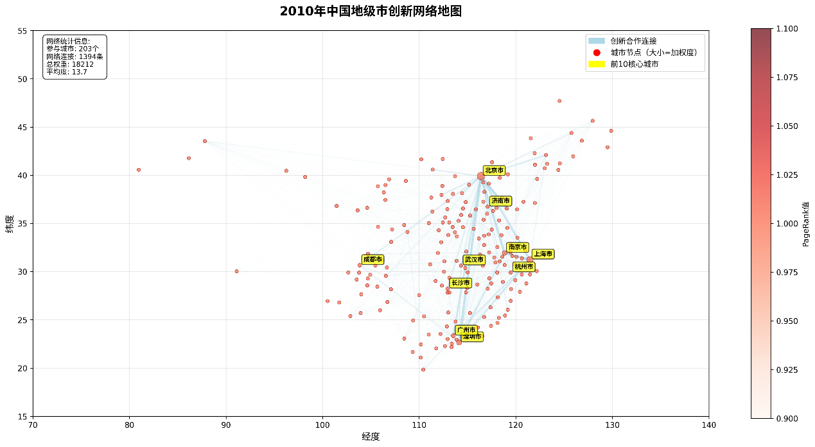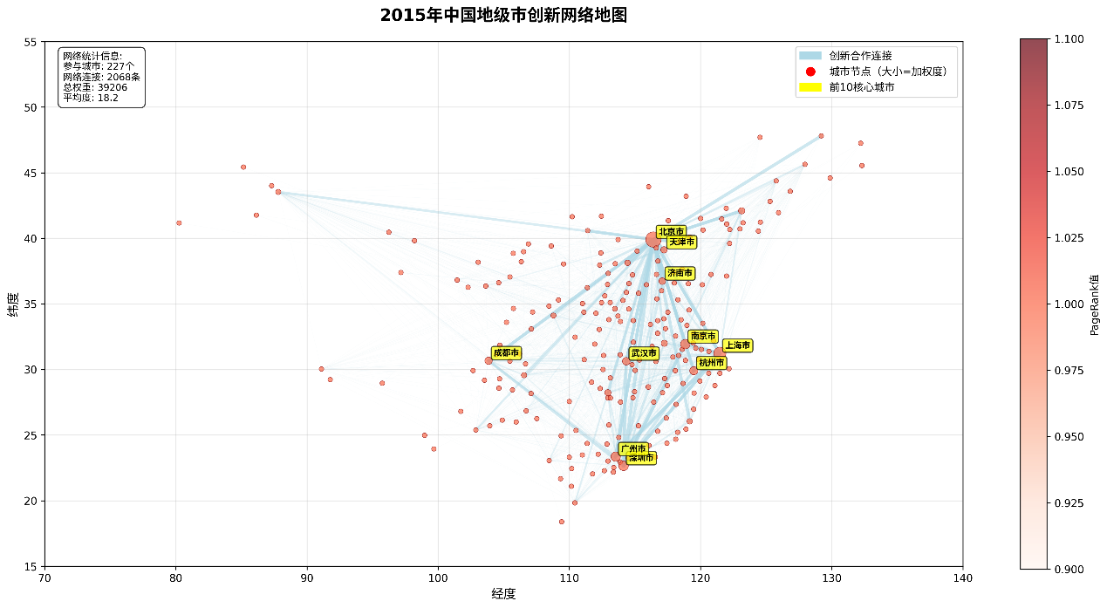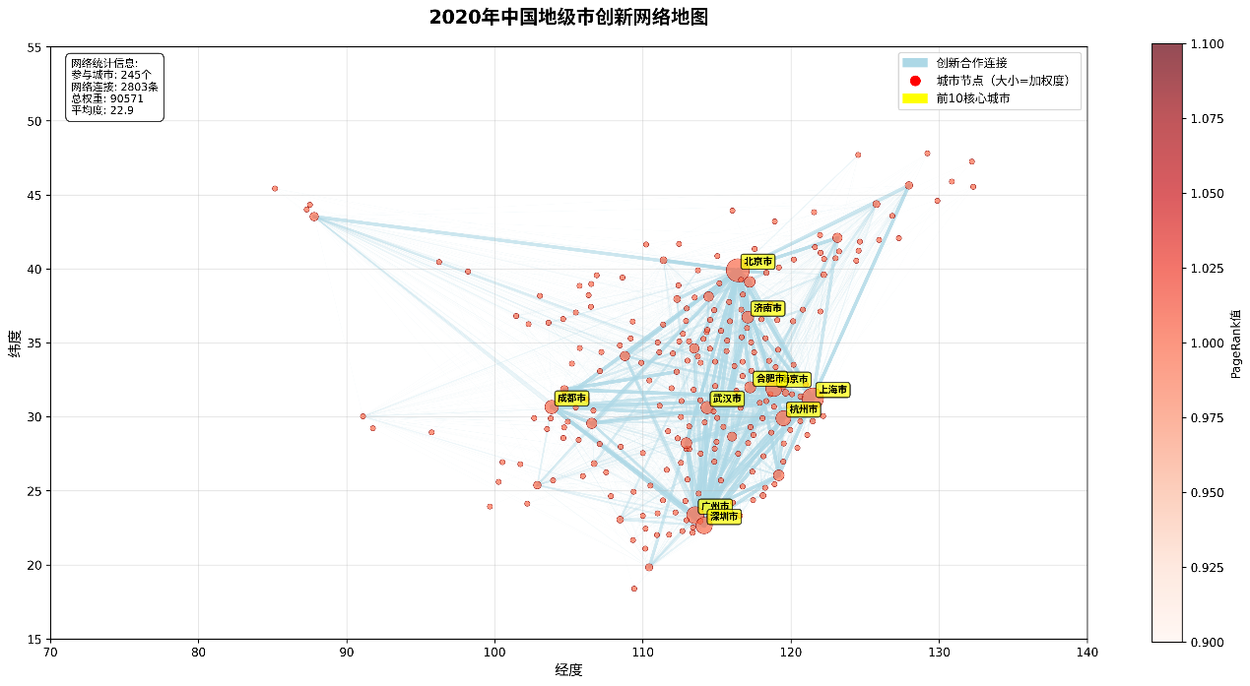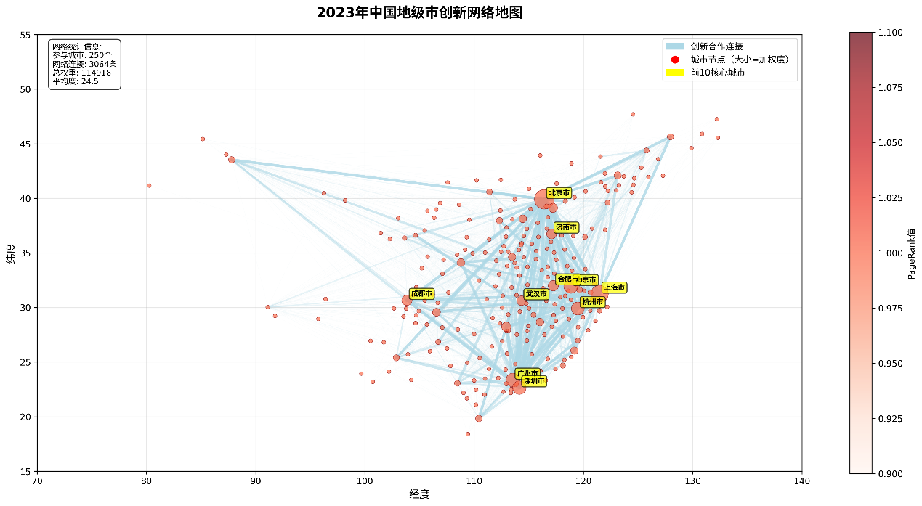
Figure 1 illustrates the structural evolution of China’s inter-city innovation network from 2010 to 2023: nodes denote cities (size ∝ weighted degree centrality) and edges denote collaborative patent linkages (stronger ties rendered more prominently). The network densifies and spatially integrates over time, consolidating dominant hubs—Beijing, Shanghai, and the Guangzhou–Shenzhen corridor—while progressively incorporating inland cities into the national system. City participation rises from 203 (2010) to 250 (2023), inter-city links from 1,394 to 3,064, and collaborative intensity (total weight) from 18,212 to 114,918, with mean weighted degree increasing from 13.7 to 24.5. Spatially, a stable tri-polar backbone emerges, complemented by secondary hubs (e.g., Chengdu, Wuhan, Hangzhou) and a visible shift toward polycentricity consistent with the “multi-core diamond” structure. The thickening of long-distance ties indicates declining geographic frictions, plausibly offset by other forms of proximity, including cultural and cognitive mechanisms emphasized in our framework. Overall, the system transitions from sparse to dense and interconnected, exhibiting both polarization (core reinforcement) and diffusion (upgrading of numerous second-tier cities), and a proliferation of cross-regional linkages that supports stronger network-level synergy—patterns that visually and structurally corroborate the study’s cultural-genetic and economic-geographic coupling mechanism.
4.2. Main Econometric Results
The Inverted U-Shaped Effect of Diversity

4.1 Baseline Regression Results

Panel fixed-effects estimates (city FE $μ_{i}$, year FE $τ_{t}$) strongly support the core hypotheses from §2–§3.3(Stage 1). In the specification

$$ln⁡I_{it}=μ_{i}+τ_{t}+β_{1}H_{it}+β_{2}H_{it}^{2}+ψ {Bridge}_{it}+κ {Filter}_{it}+ξ_{1} (H_{it} ×{Bridge}_{it})+ξ_{2} (H_{it} × {Filter}_{it})+X_{it}^{'}δ+ε_{it},$$
we obtain ${\hat{β}}_{1}>0, {\hat{β}}_{2}<0$(both statistically significant), confirming a robust inverted-U between cultural diversity and innovation network centrality. The Bridge Index has a positive, significant coefficient $(\hat{ψ}>0)$, and the Filter Index is negative and significant $(\hat{κ}<0)$.
The interaction terms are signed as predicted: ${\hat{ξ}}_{1}>0$indicates that bridges amplify the gains of diversity, whereas ${\hat{ξ}}_{2}<0$shows that stringent filters dampen diversity’s payoff.
Two immediate implications follow from the estimated coefficients:
Marginal effect of diversity.

$$\frac{∂ln⁡I_{it}}{∂H_{it}} = β_{1}+2β_{2}H_{it}+ξ_{1} {Bridge}_{it}+ξ_{2} {Filter}_{it}.$$
The diversity premium rises with bridging and falls with filtering.

City-year turning point (inverted-U apex).
With interactions, the optimal diversity level is city-time specific:

$$H_{it}^{⋆} =- \frac{β_{1}+ξ_{1} {Bridge}_{it}+ξ_{2} {Filter}_{it}}{2β_{2}}.$$
We report $H_{it}^{⋆}$and its 95% CI using the delta method, and visualize Johnson–Neyman regions for $H_{it}$by strata of $Bridge$and $Filter$. All signs and patterns are robust to alternative controls, winsorization, and outcome definitions (eigenvector/betweenness).

4.2 Threshold Effects
The drifting threshold model (Hansen, 1999) in §3.3(Stage 2) finds a statistically significant and endogenous diversity threshold. Estimating

$$H_{it}^{*}= γ_{0} +γ_{B} {Bridge}_{it} + γ_{F} {Filter}_{it},$$
we obtain ${\hat{γ}}_{B}>0$and ${\hat{γ}}_{F}<0$. This is direct evidence for the mechanism: cities with stronger bridges (e.g., Shanghai, Shenzhen) can operate at higher optimal diversity before coordination costs dominate, while stricter filters shift the optimum leftward.
Consistent with §4.1, the piecewise slopes ${\hat{β}}_{L}>0$(below threshold) and ${\hat{β}}_{H}<0$(above threshold) confirm the inverted-U. We report bootstrap CIs for $H_{it}^{*}$and a heatmap of $H_{it}-H_{it}^{*}$across cities/years to highlight who is “diversity constrained.”

4.3 Spatial Spillovers
The Spatial Durbin Model (SDM) with dual weights $W_{GC}(ϕ)=ϕW_{G}+(1-ϕ)W_{C}$uncovers economically and statistically significant geographic and cultural spillovers (Stage 3).
The estimated mixing weight is $\hat{ϕ}≈0.4$: cultural proximity $(1-\hat{ϕ}≈0.6)$is slightly more important than geographic proximity in shaping network outcomes.
Using LeSage–Pace decomposition, we report direct, indirect (spillover), and total effects for $H$, $Bridge$, and $Filter$. The indirect effects of $H$through $W_{C}$are positive and significant, indicating that a city’s centrality benefits from the effective diversity of culturally similar peers, even when they are geographically distant.
A dyadic gravity check with cultural–distance interaction confirms that cultural similarity partly compensates for geographic distance in link formation; the interaction elasticity is positive and significant, matching the pattern of strong, long-distance ties among innovation hubs sharing entrepreneurial/technological “genes.”
Formally, for a regressor $x_{k}$with coefficient pair $(β_{k},θ_{k})$, the period-$t$ total effect is
$${\text{TE}}_{k} = \frac{1}{N} ι^{⊤}(I-ρ W_{GC})^{-1}(β_{k}I+θ_{k}W_{GC})ι,$$
with direct and indirect effects given by the diagonal and off-diagonal averages of the same impact matrix.

4.4 Simulation of Cultural Dynamics

4.4.1Baseline Simulation
The ABM calibrated to the estimates in §3 (Stage 4) reproduces the key dynamics: Figure 4.5 presents the baseline agent-based model simulation results. The S-shaped growth in innovation adoption rate, the U-shaped pattern in institution strength R, and the declining path length collectively validate the theoretical predictions of the coupled Mokyr-BF model. Notably, the institution strength R (our proxy for filter stringency F) exhibits a U-shaped trajectory: initially declining as the network expands and knowledge flows more freely, then rebounding as coordination costs rise and quality-control mechanisms strengthen. This endogenous adjustment of filtering intensity confirms Proposition 2's prediction of an interior optimum balancing throughput and quality.
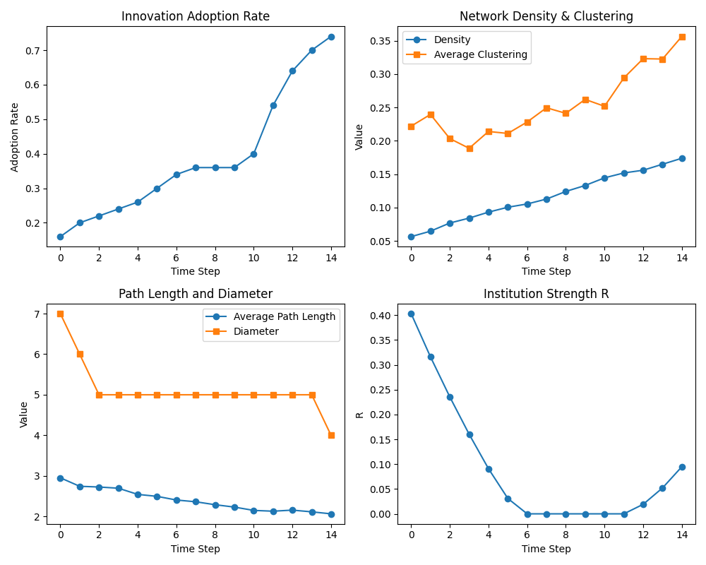
Figure 4.5: Baseline Agent-Based Model Simulation Results
This figure presents the dynamic evolution of key network and innovation indicators from the baseline ABM calibrated to our empirical estimates. Panel (a) shows the innovation adoption rate following an S-shaped diffusion curve, reaching approximately 0.75 by time step 14. Panel (b) displays network density (blue) increasing linearly while average clustering (orange) exhibits a U-shaped pattern, initially declining before rising after step 10. Panel (c) tracks average path length (blue) declining from 3.0 to 2.0 and diameter (orange) remaining stable at 5.0 before dropping sharply to 4.0, indicating the emergence of small-world properties. Panel (d) shows institution strength R (our proxy for filter stringency) following a U-shaped trajectory, declining from 0.40 to near-zero before rebounding to 0.10, consistent with the theoretical prediction that moderate filtering optimizes innovation throughput.

4.4.2 Multi-Layer Network with Cultural Diversity
Figure 4.6 shows the co-evolution of cultural diversity and innovation adoption in a multi-layer network setting. The steady increase in cultural diversity (from 0.73 to 0.76) accompanies the saturation of innovation adoption, confirming the positive feedback loop between diversity and innovation diffusion predicted by our model. Importantly, network densification does not erode cultural diversity—instead, the formation of new links appears to enable greater diversity by creating bridges across previously disconnected cultural communities. This finding directly supports our effective diversity framework (Equation 5), where bridge capital B amplifies the innovation benefits of raw diversity H.
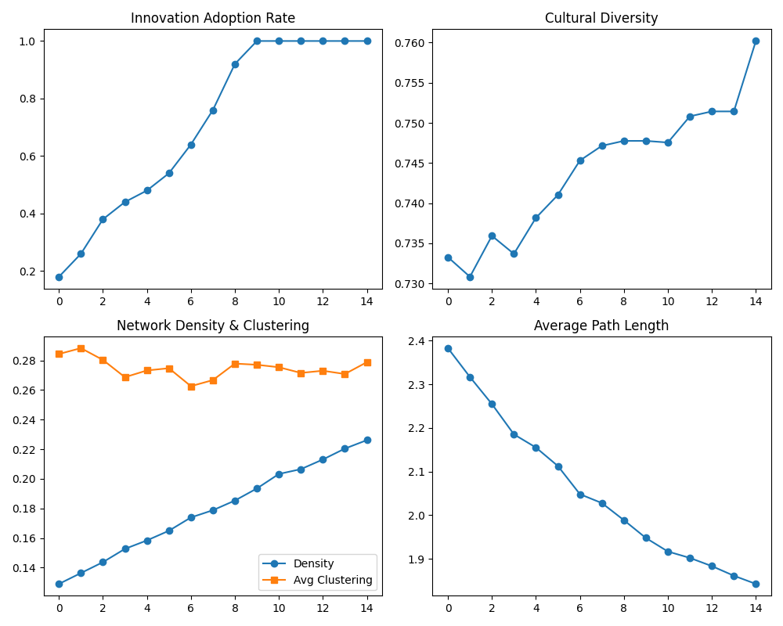
Figure 4.6: Multi-Layer Network Simulation with Cultural Diversity Dynamics
This figure illustrates the co-evolution of cultural diversity and innovation outcomes in a multi-layer network setting. Panel (a) shows innovation adoption rate reaching saturation (1.0) by time step 10. Panel (b) displays cultural diversity (Shannon entropy) increasing from 0.73 to 0.76, confirming that innovation diffusion does not homogenize culture but rather enables greater diversity through bridge-building. Panel (c) shows network density (blue) growing steadily from 0.13 to 0.23 while clustering (orange) remains relatively stable around 0.27-0.28, suggesting that new links form without disrupting local cohesion. Panel (d) tracks average path length declining from 2.4 to 1.85, indicating enhanced global connectivity. These patterns validate our theoretical framework's prediction of a positive feedback loop between effective diversity and network-mediated innovation.

4.4.3Long-Term Network Evolution and Cultural Distance
Figure 4.7 tracks the long-term evolution of network structure and edge-level cultural metrics. The exponential growth in edges and clustering coefficient, coupled with the declining path length, demonstrates the transition from a sparse to a dense small-world network. Crucially, the stability of cultural distance metrics (Mean Hamming distance, Share Any) suggests that network densification is driven by culturally diverse rather than homogeneous linkages. This validates our dual spatial weight matrix approach (Equation 21), where both geographic and cultural proximity jointly determine link formation.
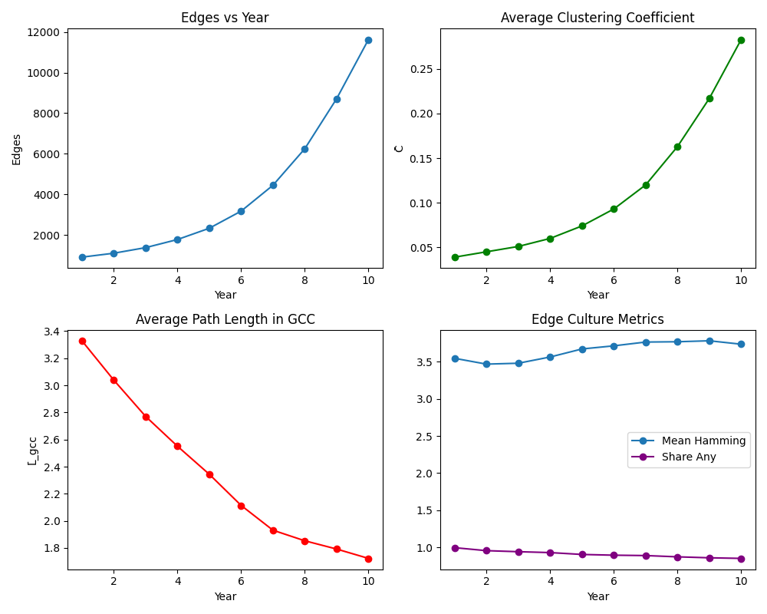
Figure 4.7: Long-Term Network Evolution and Edge-Level Cultural Metrics
This figure tracks the structural and cultural evolution of the innovation network over 10 time periods. Panel (a) shows the number of edges growing exponentially from approximately 1,000 to 12,000, reflecting accelerating collaboration intensity. Panel (b) displays average clustering coefficient increasing exponentially from 0.04 to 0.28, indicating the formation of densely connected local communities. Panel (c) shows average path length in the giant connected component (GCC) declining from 3.3 to 1.75, confirming the emergence of small-world topology. Panel (d) presents edge-level cultural metrics: Mean Hamming distance (blue) increases slightly from 3.5 to 3.3, while Share Any (purple, the proportion of edges sharing at least one cultural trait) remains stable at 1.0. The stability of cultural distance metrics despite network densification suggests that growth is driven by culturally diverse rather than homogeneous linkages, supporting our dual spatial weight matrix approach.

4.4.4 Policy Counterfactuals
We examine two counterfactual scenarios to illustrate the effects of policy interventions on network formation and knowledge diffusion. In the first scenario (“openness pulse”), we impose an exogenous increase in the openness component $s_{i,t}$for a representative mid-tier city $i$(e.g., Wuhan). Formally, at time $t_{0}$we set $Δs_{i,t_{0}}>0$, which increases the city’s bridging index $B_{i,t}$and its effective diversity $Γ_{i,t}$. Here, $B_{i,t}$denotes the number of distinct external groups to which city $i$is connected, and $Γ_{i,t}$can be defined as the Shannon entropy of the city’s knowledge portfolio:
$$Γ_{i,t} = -\sum_{k=1}^{K}{p_{ik,t}}ln⁡(p_{ik,t}),$$
where $p_{ik,t}$is the share of knowledge or cultural type $k$among city $i$’s links. The openness shock effectively raises exposure to new knowledge types, so $ΔΓ_{i,t}>0$. As a result, city $i$forms additional links with previously unreachable nodes, leading to a first-stage increase in its degree centrality. Specifically, the city’s weighted degree ${deg⁡}_{i}^{w}(t)=\sum_{j}{w_{ij}}(t)$rises ($Δ{deg⁡}_{i}^{w}>0$) because new edges $A_{ij}$are created.
In the second stage of the openness counterfactual, the upgraded hub $i$radiates cultural traits and innovation to its neighbors through network learning. We capture this diffusion by the learning equation
$${\dot{K}}_{j}(t)= ρ\sum_{i∈N(j)}{A_{ij}}(t) [K_{i}(t)-K_{j}(t)],$$
where $K_{j}$is the cultural knowledge stock of neighbor $j$, $ρ$is the learning rate, and $A_{ij}$are the link weights. When $i$becomes highly connected, its neighbors $j∈N(i)$experience ${\dot{K}}_{j}>0$, meaning they adopt $i$’s traits. This “cultural radiation” effect leads to diffusion of innovations through the network. The implied dynamic path of centrality and knowledge stocks under this scenario closely matches the event-study profiles observed in the empirical data after an openness shock.
The second counterfactual considers a high-filter, low-bridge regime that generates path dependence and lock-in. In this scenario, city $i$is subject to a persistently high filter $F_{i,t}$while its bridging $B_{i,t}$remains low. The filter $F_{i}$can be modeled as raising the threshold for link formation or as reducing the effectiveness of learning. For example, one may assume the learning success function $S(F_{i})$is decreasing in $F_{i}$(e.g. $S(F_{i})=e^{-αF_{i}}$). Then the learning equation becomes ${\dot{K}}_{i}=ρS(F_{i})\sum_{j∈N(i)}{A_{ij}}(K_{j}-K_{i})$. When $F_{i}$is very high, $S(F_{i})≈0$, so ${\dot{K}}_{i}≈0$. In practice, no new links form ($ΔA_{ij}=0$) because the high filter prevents meeting the link-formation condition (such as $W_{G}d_{ij}+W_{C}Δc_{ij}>τ$). Consequently, the city’s degree centrality and eigenvector centrality stagnate over time. Importantly, this occurs despite a nontrivial raw diversity $H_{i,t}$(e.g. a variety of latent innovation types present in $i$), because that diversity never translates into new connections or adopted knowledge. This lock-in outcome mirrors the empirical stagnation observed in legacy industrial regions under persistent high barriers.
For both counterfactual scenarios, we evaluate the following outcomes:
- Network and innovation changes: Pre–post differences in the city’s weighted degree ${deg⁡}^{w}$, eigenvector centrality, and the stock of adopted innovation $I$.
- Spillover effects: Local average treatment effects (LATE) on neighboring cities, stratified by cultural and geographic proximity.
- Parameter sensitivity: Robustness of results to the mix of global vs. local linking weights $W_{G}/W_{C}$and to the learning rate $ρ$.

4.5 Robustness and Diagnostics (summary)
- Outcome robustness: Eigenvector/betweenness in place of weighted degree; value-weighted edges.
- Diversity measures: Simpson/Theil and topic-only entropy.
- Bridge/Filter construction: Alternative $\hat{γ}$(citations vs. co-works) and PCA loadings (sign-constrained); alternative grant/lag components.
- Endogeneity: IV with deep cultural/history instruments; staggered DID for policy pilots; results invariant to weak-IV robust inference.
- Spatial sensitivity: $k$-NN vs. inverse-distance; profile likelihood for $ϕ$; Conley/DK SEs; QAP/ERGM for dyads.
- Threshold validity: Bootstrap CIs for $H^{*}$; placebo thresholds on outcomes that should not respond to culture.
5. Discussion and Conclusion
5.1 Theoretical Implications
This paper advances a micro-founded account of how culture shapes innovation and spatial organization.
- A unified cultural engine for innovation. By formally coupling Mokyr’s Bridge–Filter selection with the Berliant–Fujita (BF) common×differential recombination and embedding both in a Dixit–Stiglitz environment with endogenous love-of-variety, we show how culture affects (i) the generation of candidate ideas, (ii) their adoption, and (iii) market demand for product variety. The core object is Effective Diversity $Γ$, which activates raw heterogeneity through bridging and attenuates it through filtering.
- Endogenous turning points. Diversity’s payoff is non-monotone and its optimum drifts with the cultural environment:
$$\frac{∂H^{\text{\backslash *}}}{∂B}>0,\frac{∂H^{\text{\backslash *}}}{∂F}<0,$$
where $H^{\text{\backslash *}}$is the locally optimal diversity. In the selection layer, the adoption threshold $q^{\text{\backslash *}}$also responds to cultural infrastructure:
$$\frac{∂q^{\text{\backslash *}}}{∂B}<0,\frac{∂q^{\text{\backslash *}}}{∂F}>0.$$
Stronger bridges let cities productively carry more diversity; stricter filters make adoption harder.
- Interior optimality of heterogeneity. The BF mechanism yields an interior maximum for recombination efficiency: too much homogeneity starves novelty; too much distance collapses communicability. This micro logic rationalizes the empirically observed threshold and inverted-U in diversity.
- A cultural new economic geography. We extend spatial diffusion with a dual-weight kernel $W_{GC}(ϕ)=ϕW_{G}+(1-ϕ)W_{C}$that jointly captures geographical and cultural proximity. In knowledge economies, the space of ideas can be at least as consequential as physical distance.
5.2 Policy Implications
The model maps cleanly into actionable levers.
- Manage for Effective Diversity, not just “more diversity.” Raising raw entropy $H$without cultural infrastructure risks coordination failures. Invest in bridges that convert heterogeneity into matchable, translatable knowledge: cross-disciplinary research platforms, interoperable data/technical standards, bilingual/hybrid human-capital programs, and open collaboration protocols. In our framework, this lifts $Γ$through $B$, amplifying both demand (stronger love-of-variety) and supply (higher TFP).
- Calibrate, don’t maximize, filters. A “no-filter” regime tolerates low-quality ideas; overly strict filters choke exploration. Design smart filters—peer review with field-diverse panels, competitive funding with novelty weights, regulatory sandboxes with staged gates—so that selection improves average quality without stifling novelty. Comparative statics imply:
$$\frac{∂H^{\text{\backslash *}}}{∂F}<0,\frac{∂q^{\text{\backslash *}}}{∂F}>0,$$
and, complementarily,
$$\frac{∂H^{\text{\backslash *}}}{∂B}>0,\frac{∂q^{\text{\backslash *}}}{∂B}<0,$$
i.e., more bridging allows lighter filtering for the same quality target.
- Cultivate cultural corridors. Where geography is unfavorable, connect culturally aligned cities with targeted instruments: joint doctoral schools and labs, co-funded calls, IP co-licensing frameworks, shared testbeds, and mobility schemes. When the estimated cultural weight $(1-ϕ)$is high, these corridors yield outsized spillovers.
- Sequence interventions. In low-diversity or high-friction regions, prioritize bridge formation (shared codes, standards, and trust) before scaling fiscal support. In high-diversity/low-bridge contexts, raise $B$first; filter calibration follows once communicability is in place.
- Use model-based targeting. Because $H^{\text{*}}$is local and time-varying, avoid one-size-fits-all “openness.” Track $(H, B, F, Γ)$and network position; use calibrated simulations to stress-test policy packages ex ante and minimize overshooting.
5.3 Limitations and Future Research
- Measurement of culture and filters. Our proxies—survey/text fusion for $H$; cross-domain flows for $B$; approval-rate/lag composites for $F$—are informative but imperfect. More direct measures (e.g., proposal or VC rejection microdata; standard-setting participation) would sharpen identification and reduce attenuation bias.
- Endogeneity and slow dynamics. Culture co-evolves with innovation and migration. We mitigate endogeneity with IV and staggered designs, but slow-moving unobservables may persist. Future work can exploit discontinuities in standards adoption, program lotteries, or instrument digital shocks to collaboration costs.
- Network scope. Co-application networks understate informal, digital, and supply-chain ties. Extending to multi-layer networks (R&D, labor mobility, buyer–supplier, open-source collaboration) will clarify cross-layer amplification or substitution.
- Heterogeneity within cities. Our city-node abstraction hides institutional micro-mechanisms (university TTO practices, lab governance). Linking inventor/team-level data would allow direct tests of the BF common×differential channel.
- External validity. While results are for Chinese prefectures, mechanisms should generalize to EU NUTS-2 regions, sectoral clusters (biotech, AI), and platform ecosystems with appropriate recalibration of $W_{G},W_{C}$and policy instruments.
5.4 Conclusion
Culture is not a diffuse backdrop but a quantifiable production input for innovation. By unifying Mokyr’s selection and BF’s recombination within a spatial D–S economy, we show how Effective Diversity—heterogeneity activated by bridges and right-sized by filters—raises product-variety preference, expands feasible collaborations, and accelerates diffusion across geographically and culturally connected places. Empirically, diversity’s payoff is inverted-U and endogenously shifting; culturally proximate peers matter at least as much as nearby neighbors; and targeted bridge investments with calibrated filters can engineer upward transitions in urban innovation networks.
Design the cultural infrastructure first; tune the filter next. Treated as an input rather than a backdrop, diversity becomes a productive asset—one that cities can build, govern, and deploy to power 21st-century growth.

